**Manuals for ‘Manage Home Slider’**

**Brief of the ‘Manage Home Slider’ –** This is the page where we manage the images of home page slider.

**1. How to manage home slider -.**

Steps:

1. Login to the site and go to ‘Masters’ tab and click on ‘Manage home slider’.
2. On ‘Manage home slider’ page there is listing of slider image and ‘Add new home slider’ button.
3. We can edit and delete the existing records on clicking of edit and delete button respectively.
4. For add new image, click on ‘Add new home slider’ button.
5. Fill all the entries and click on ‘Save’ button for save new records.
6. This image will display home slider.

1.

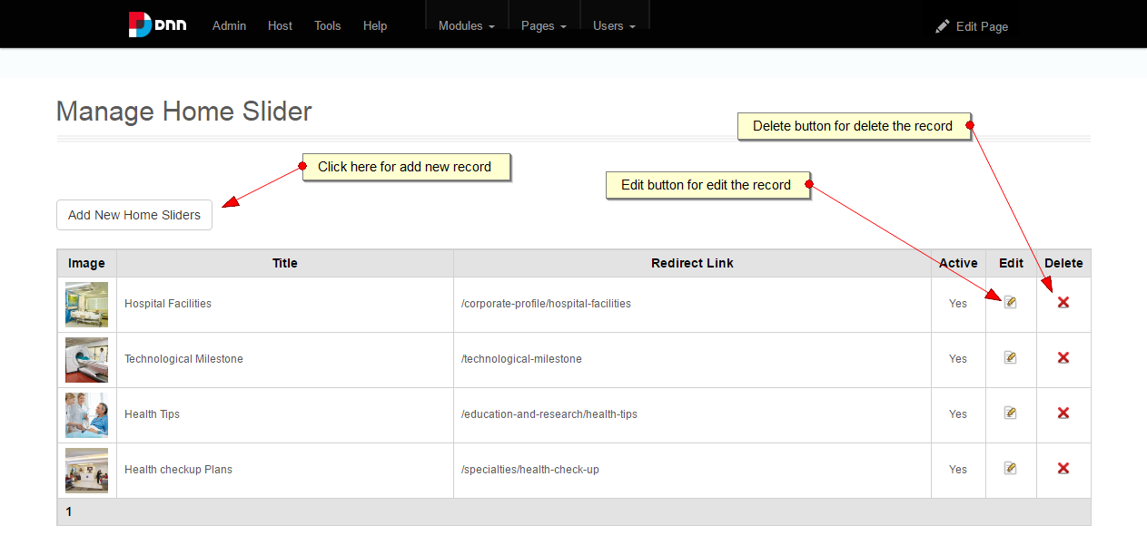

2.

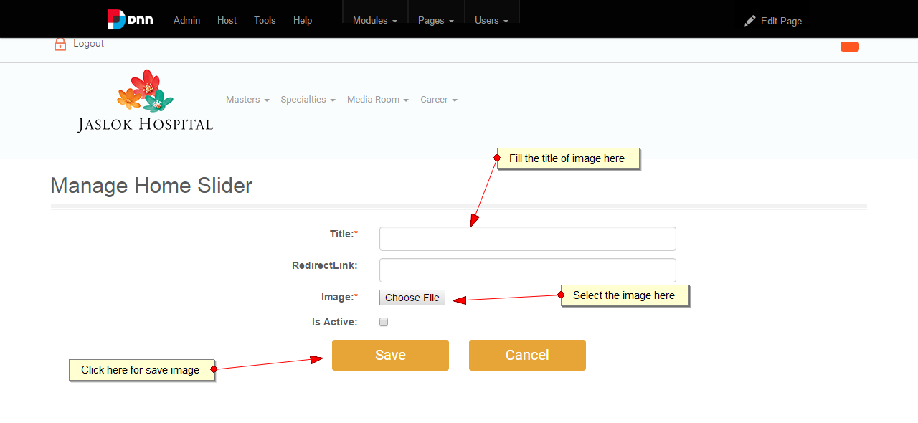

3.

